* **SDA(SCREEN DESIGN AID)** is application development tool in AS400 which assists in designing screens.
* The **CL command STRSDA** is the primary command for the IBM Screen Design Aid (SDA) utility. This command can be invoked in all three environments of the system.
* We put the plane text inside quotes and press ENTER, to display it on the screen
* While designing to blank out any character on the screen, never use Backspace/Delete key as it leads to bad alignment of the screen content. Rather we press ‘SPACE’ button to blank out any character.
* *USER, *DATE, *TIME these are the keyword that you can use to place USER NAME, CURRENT SYSTEM DATE and SYSTEM TIME.
* **How to define fields in screens**.

+3(LENGTH) = To define input numeric fields.

+6(Length) = To define output numeric fields

+9(length) = To define both input and output numeric field.

+I(LENGTH) = To define input character fields.

+O(Length) = To define output character fields

+B(length) = To define both input and output character field.

* Once source member gets created, if we need to do any further modifications on screens, we can use option 17 from PDM window (output of WRKMBRPDM).
* **To define indicator keywords.**

Once you enter inside use option 8 and then select 2nd option for indication keywords.

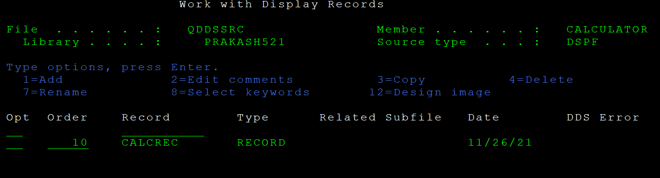



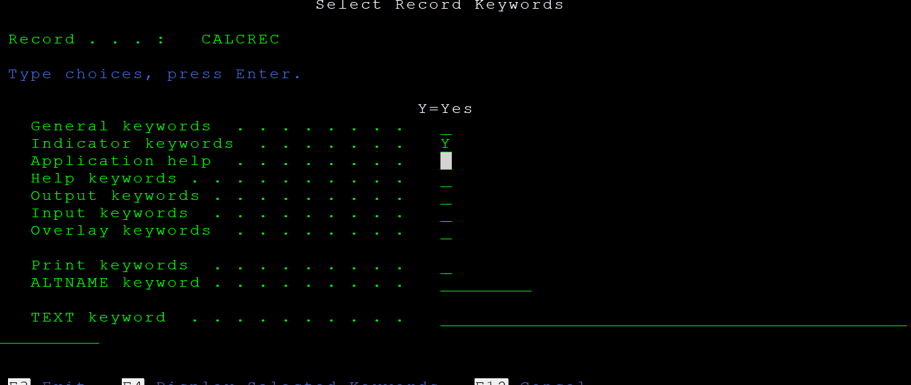

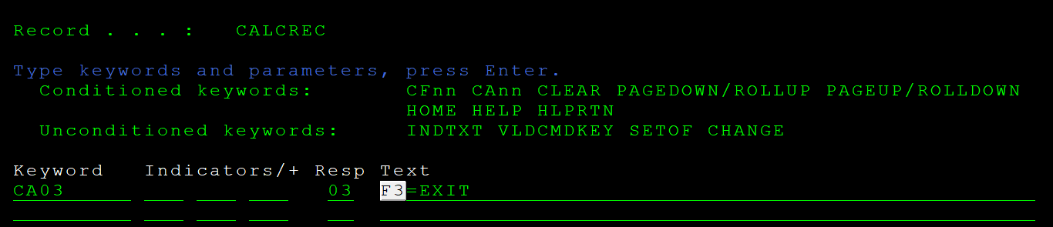

* How to define screen file in rpgle?

In F-SPEC , File type will be ‘C’ (combined) and device will be WORKSTN .

**Sample program**

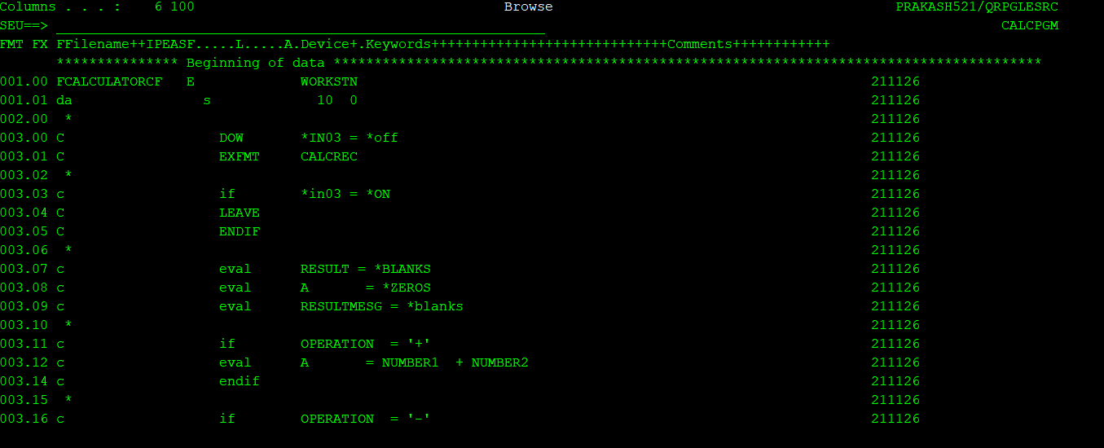

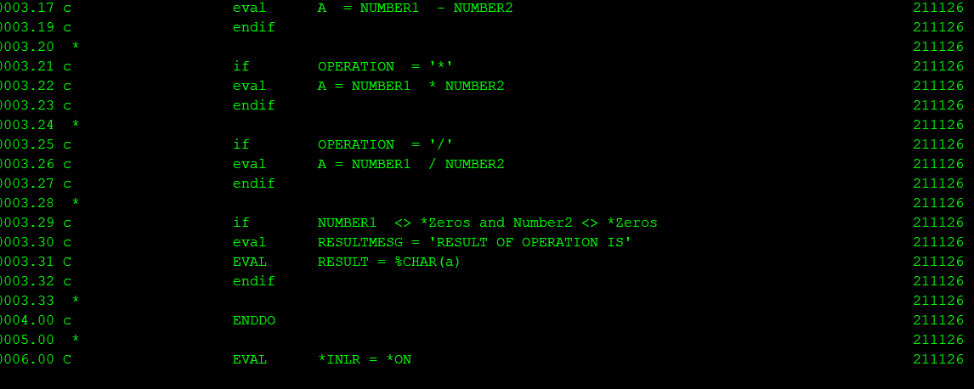

**DSPATR keywords: -**

PROTECT/HIGH INTENSITY/REVERSE IMAGE (IN CASE OF ERRORS)/BOLD

**Subfile:**

This is displaying records in a tabular format on a display device.

1.Subfile size(Total records to be contained in a subfile)

2. Subfile page size(Total records to be contained in one page of a subfile)

3. Subfile control and subfile format.

4.SFLCLR (Subfile clear) define an indicator for this.

5.SFLDSPCTL (to display control format ) and SFLDSP(To display subfile/data format)

Types of subfiles based on subfile size and subfile page size

1. Load all subfile

Entire subfile will be loaded at once.

In this case SUBFILE SIZE > SUBFILE PGE

In this case Pageup and pagedown will be taken care by system

This can be used only when we know that total records in subfile cant exceed 9999

Maximum subfile size can be 9999 records.

1. Single page subfile.

This is loaded page by page

Subfile size = subfile page

PAGE UP and pagedown are taken care by system.

1. Extendable/elastic Subfiles

Subfile size > subfile page by 1

1In this case programmer has to take care of pagedown

A subfile’s process can be divided mainly into 3 parts:

***1.  Clearing the subfile control record format.***

***2.  Loading the subfile buffer with the relevant data.***

***3.  Displaying the data from subfile buffer to the display device.***

·         CHAIN, READC, UPDATE, or WRITE operation codes can be used for subfile record format to transfer data between the program and the subfile.

·         READ, WRITE, or EXFMT operation codes cane be used for subfile control-record format to transfer data between the program.

·         EXFMT first of all write the keyboard input to the screen (to the screen field variable) and then read it. Hence by write operation we can have the value in the screen field available.

·         Session or device error comes when there are no records in the database to fill the subfile.

READC & SFLNXTCHG

**READC:**  
  
READC is used to Read the Changed Records in a Subfile.

**Modified data tag (MDT) t**his is kind of indicator. Whenever record in subfile is changed this will be ON. Readc reads all records where MDT is ON and once read it makes MDT OFF.

OPTION EMPID EMPNAME

2 --🡪 Initially MDT was on and then Readc read this **and made it OFF**. Later is some one needs to change this again say option 4 needs to be used. So MDT is Off now.. To read second level-3rdlevel-4th level changes on same record, we will use **SFLNXTCHG INDICATOR.**

**Sflnxtchg = IN95**

3  
4

Sample code will be…

READC SFL

DOW NOT %EOF()

PROCESSING BASED ON OPTIONS (Select when or If conditions)

Switch on sflnxtchg Indicator(*in95 = ‘1’)

Update sfl

Switch off Sflnxtchg (*in95= *off)

readc

ENDDO  
**SFLNXTCHG:**  
  
SFLNXTCHG is used to mark the Records in a Subfile as Changed.  
  
SFLNXTCHG plays a Major role when there is a Subfile with Update capabilities.  
  
While processing the Subfile, Changed Records can be read using 'READC'. However, In most cases where Update is involved it is essential to validate the data before Update.  
  
Modified tag would be automatically turned off on a record when Program reads the Changed Record (using READC) for validation and wouldn't be able to read the record again for the actual UPDATE operation.  
  
This can be controlled using SFLNXTCHG Keyword.  
  
SFLNXTCHG can be used in two different ways.

1. Use SFLNXTCHG Keyword without any indicator
2. Control SFLNXTCHG Keyword with indicator.

Using SFLNXTCHG without any indicator would mark all the records written into Subfile as Changed by default. And, all of these records can be read by READC even if there is no Change has been done by the Screen User.  
  
This may take more time in processing the subfile and may not be required to read all the records specially when there are large number of records in Subfile.  
  
Controlling SFLNXTCHG Keyword with indicator would be preferred in these cases.  
  
When a record is changed, Record would be marked as 'Changed' by default and can be read using READC. Turn ON the Indicator on SFLNXTCHG Keyword once the record is read using READC and UPDATE the Subfile. This would mark the record as 'Changed' and can be read again using READC.

**SFLINZ and SFLRNA**

These two keywords is **used to initialize a subfile** which is done in case we want to make a data entry screen. After the entry is made to be the subfile then only it becomes active, before that it will be inactive. This is done by SFLRNA.

Consider a EDTLIBL output, it gives blank lines and we can just insert values and enter. It gets updated, similar functionality, if we need to achieve in subfiles we can use these keywords.

**SFLCSRRRN**

·         This keyword is used to provide the relative record number (RRN) of the record on which cursor is placed.

**SFLRCDNBR**

·         This keyword is used at field level.

·         It is used to display the page having RRN value that is in the hidden field defined as a parameter of SFLRCDNBR.

·         If we do not specify this keyword, first page of the subfile is displayed by default.

·         The format of the keyword is:

·         SFLRCDNBR ( CURSOR  or   *TOP)

·         Here, if CURSOR is specified as parameter, then the cursor will be placed at the record whose RRN value is in the hidden field(RCDNBR below).

A RCDNBR 4S 0H SFLRCDNBR(CURSOR)

·         Here, if *TOP is specified as parameter, then the very first record that will be displayed on the subfile screen, is the one having RRN value as specified in the hidden field.

From INFDS data structure 378 to 379 we will get first rrn of current page.

Basically, when we need to have our display stay on the same page move this value from INFDS to SFLRCDNBR field. It will stay on same page.

**Example: -**

**SFLRECD is SFLRCDNBR defined in subfile**.

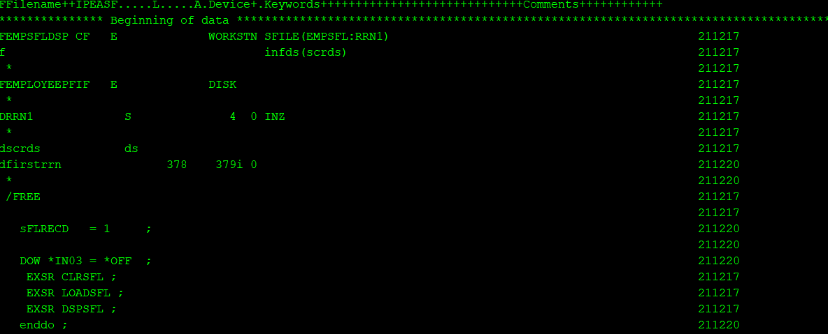

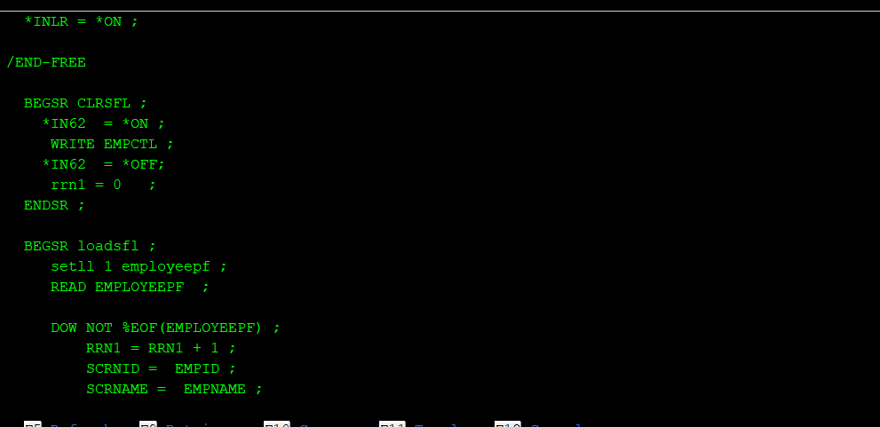

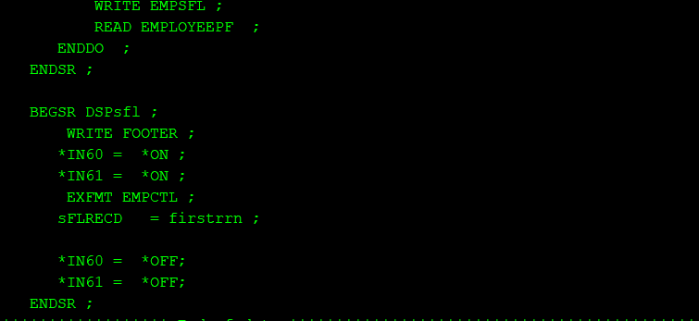

**Subfile example in SQLRPGLE using external and multioccurence data structure:**-

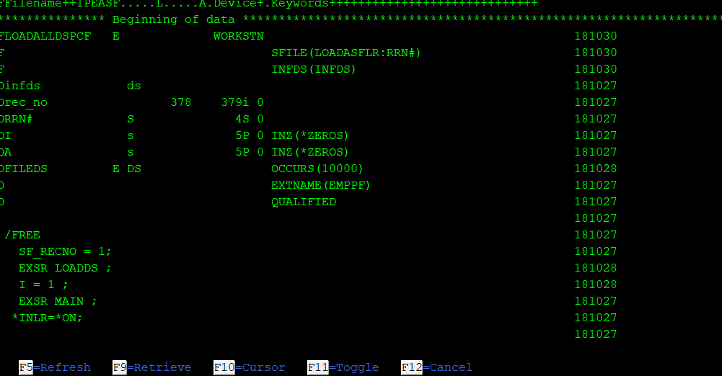

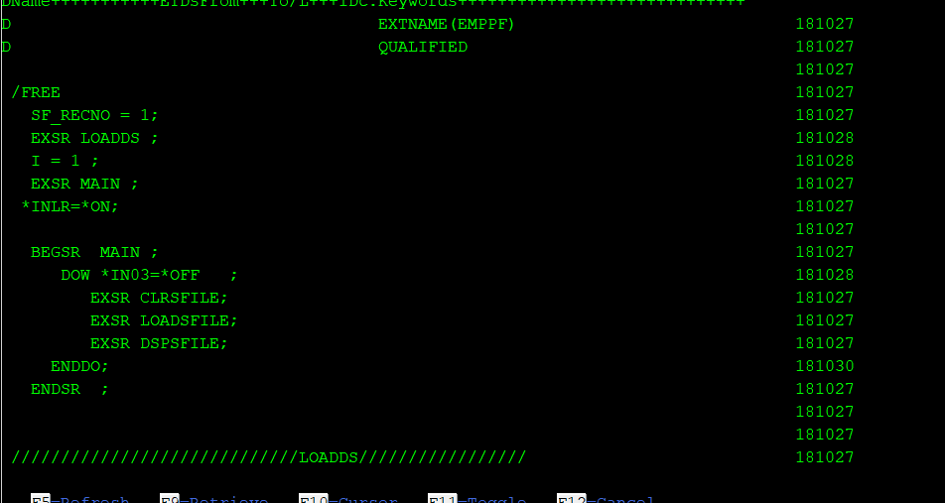

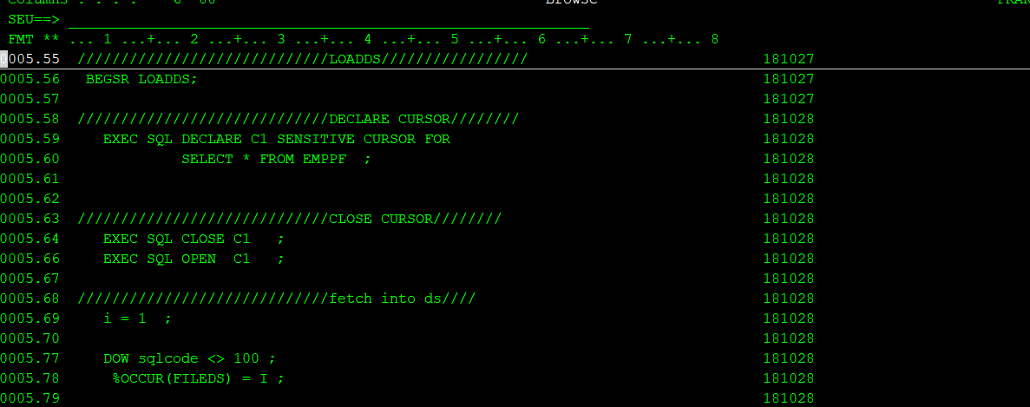

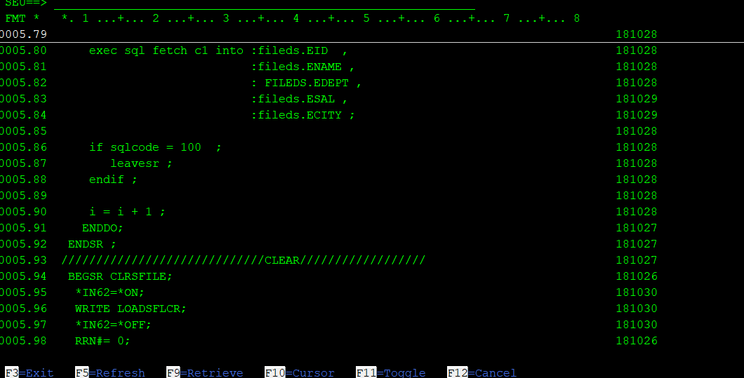

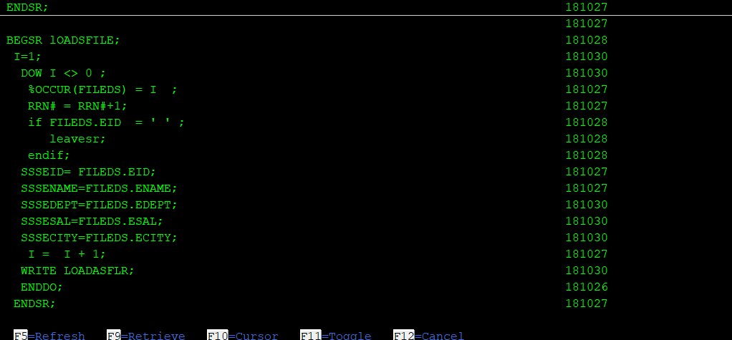

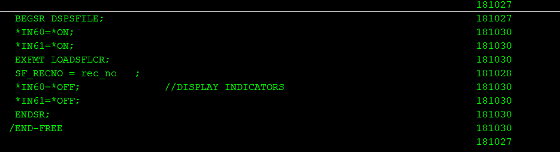

**Note : -**

For free format it is no longer mandatory to use /FREE and /END-FREE now with newer

releases. Even if /free and /end-free has been used in examples it is not mandatory.

**SFLDROP**

You use this record-level keyword on the subfile-control record format to assign a command attention (CA) key or a command function (CF) key that the workstation user can press to fold or truncate subfile records that require more than one display line.         .

Ü **SFLFOLD**

You use this record-level keyword on the subfile-control record format to assign a command attention (CA) key or a command function (CF) key that the workstation user can press to truncate or fold subfile records that require more than one display line.

**Single Page subfile : -**

Page up and Page down has to be coded by programmer

One page will be loaded at once.

**ROLLUP/ROLLDOWN**

ROLLUP /Page down indicator: This will be used to define page down indicator. Indicator defined with this keyword will be ON once user presses Page down. Programming for page down can be controlled by this indicator.

**ROLLDOWN/PAGEUP**

ROLLDOWN /Page UP indicator: This will be used to define page UP indicator. Indicator defined with this keyword will be ON once user presses Page UP on screen. Programming for page down can be controlled by this indicator

ROLLDOWN /Page up indicator)

**Extendable/Elastic subfile: -**

Here pages of subfile are loaded on demand. Subfile size keeps growing hence its called ELASTIC or extendable subfile.

Pagdown is handled by programmer as next page is loaded based on PAGEDOWN request from user.

Pageup will be handled by system and records remain in buffer, whenever page down is pressed only new set of records are loaded in next page of subfile, but without clearing previous data in subfile buffer, hence page up is automatically taken care by system as data will still remain in buffer.